**Exercise**

**Databases**

**Name: Mahesh Inder**

**Problem Statement: There can be multiple customers, who can place multiple orders on the site. Now a sales person can handle these orders will distribute into multiple sales persons (One order will be assign to one salesperson only). So a sales person can have multiple orders of multiple customers.**

1. **Create Database.**
2. Databases can be created by using “create database db_name” command.

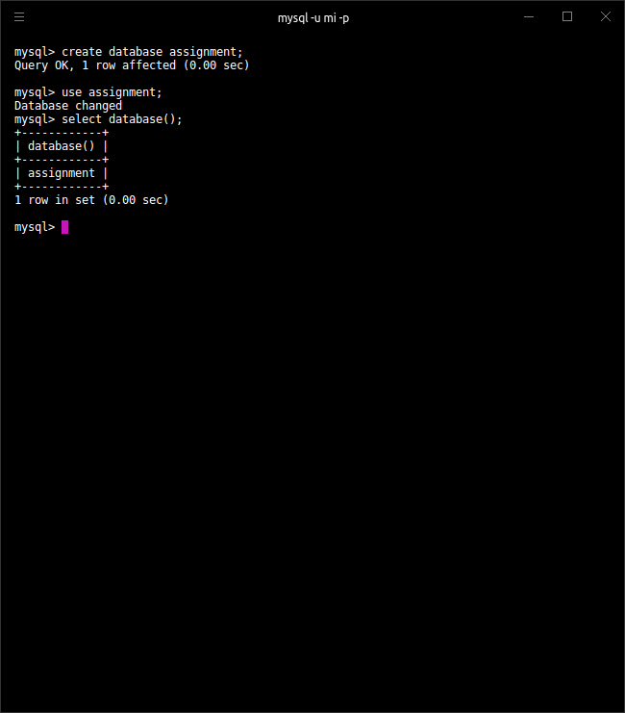

1. **Design Schema**

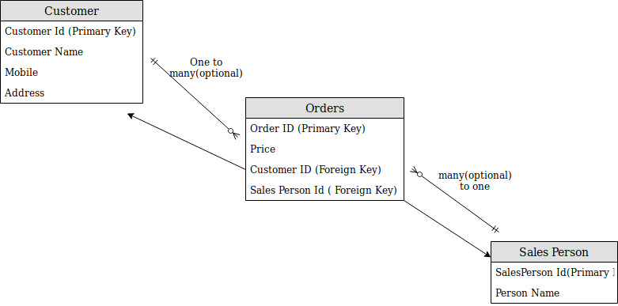

**ER Diagram**

**(Schema for the given Problem)**

1. **Create tables.**
2. Using create table command to create table:

* Customer table :
* Seller and Orders tables:

Let’s have a look at created tables.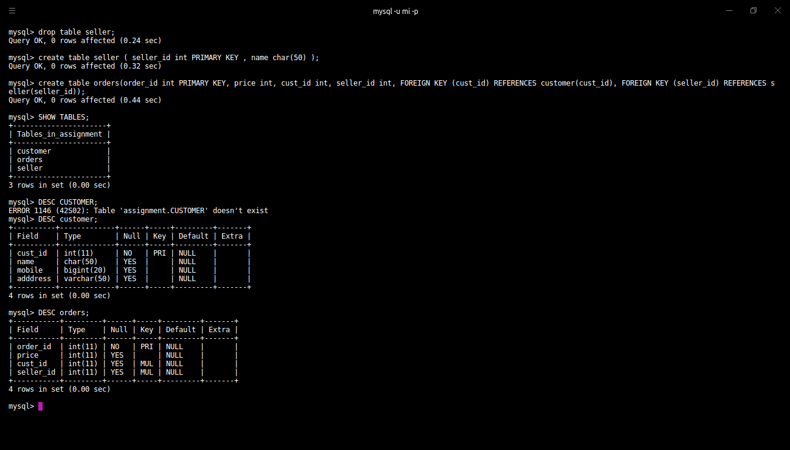

Seller table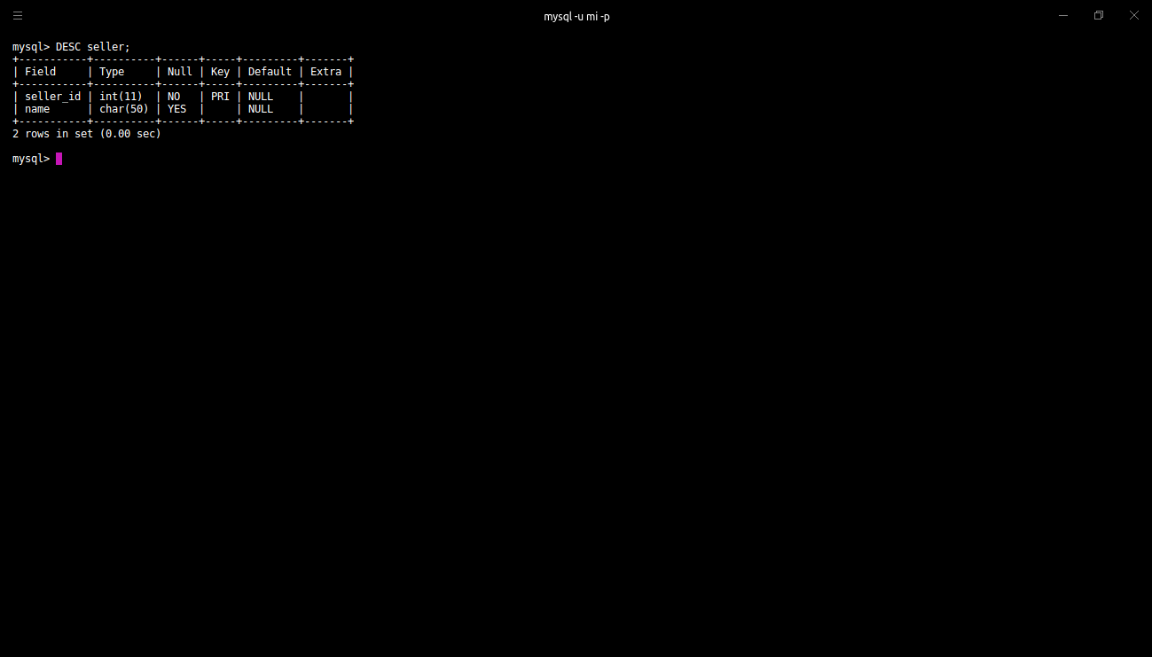

**4. Insert sample data.**

1. Using insert command, data can be inserted into the table.

*Insertion in Customer table.*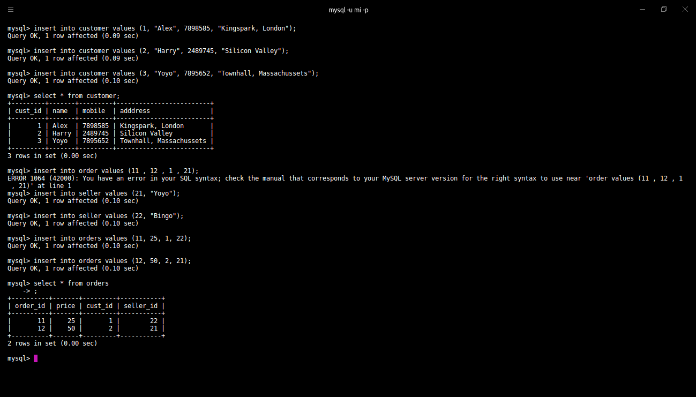



*Insertion in Seller table.*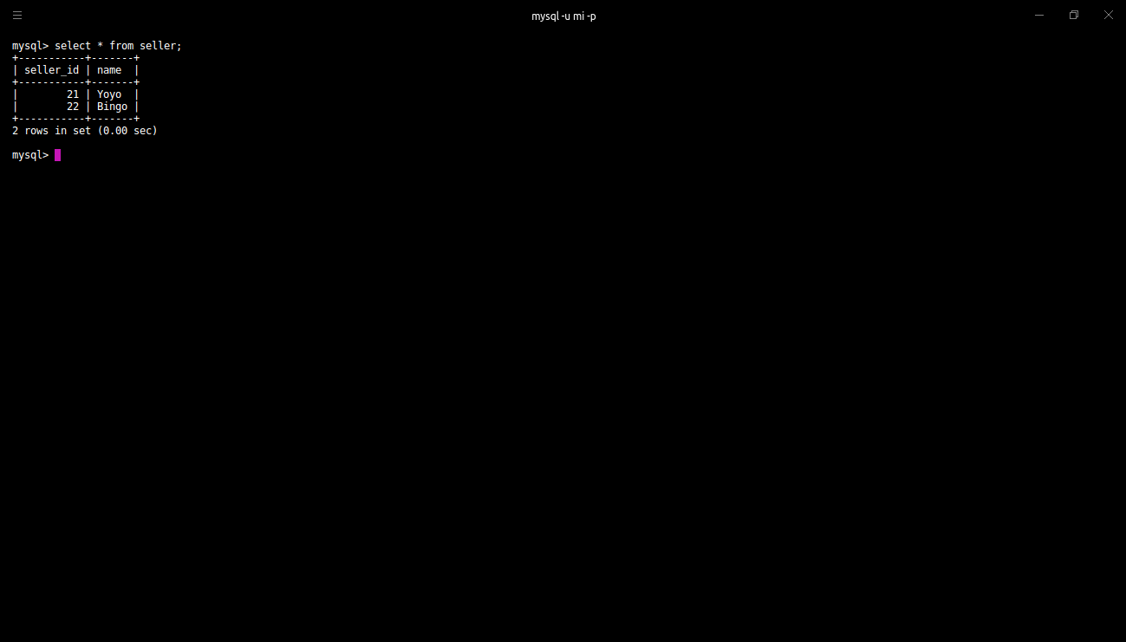

*Insertion in Orders table.*

1. **Find the sales person have multiple orders.**
2. To display the details of the seller who has multiple orders, we will group the data by seller_id and display the results where the count is more than one.

Command : SELECT *o.seller_id, s.name*, COUNT(*) FROM *orders o, seller* s WHERE *o.seller_id = s.seller_id*  GROUP BY *o.seller_id* HAVING COUNT(*) > 1;

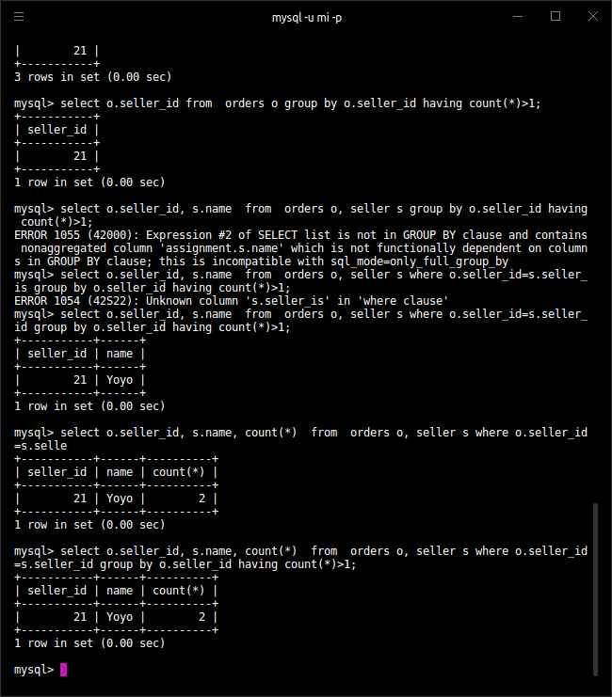

1. **Find the all sales person details along with order details.**
2. By using where clause we can filter the data before projecting it.

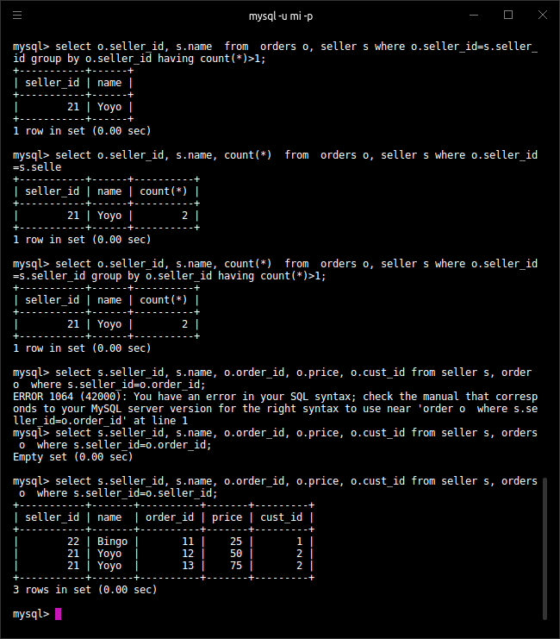

1. **Create index.**
2. Command used: create index index_name on tableName(columnName)

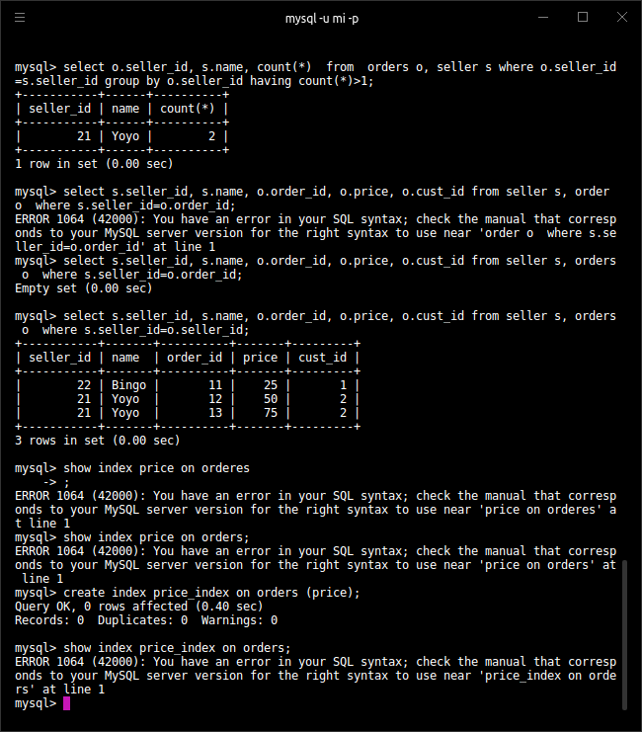

1. **How to show index on a table**
2. Command used: show index from tableName

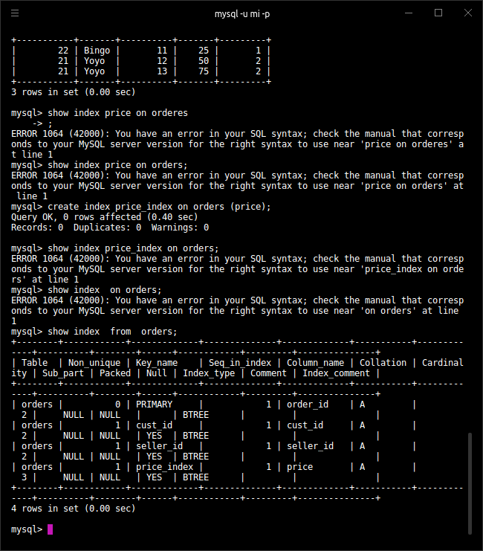

1. **Find the order number, sales person name, along with the customer to whom that order belongs to.**
2. Command used: SELECT *o.order_id* AS *order_number, s.name* AS *seller_name, c.name* AS *customer* FROM  *orders o, seller s, customer c* WHERE *s.seller_id = o.seller_id && o.cust_id = c.cust_id;*

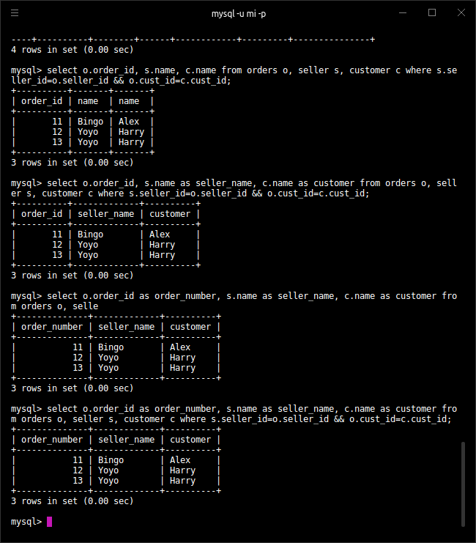

*Usage of where clause with &&.*